**GITHUB DOCUMENT FOR C PROGRAMMING:**

1 OPERATORS: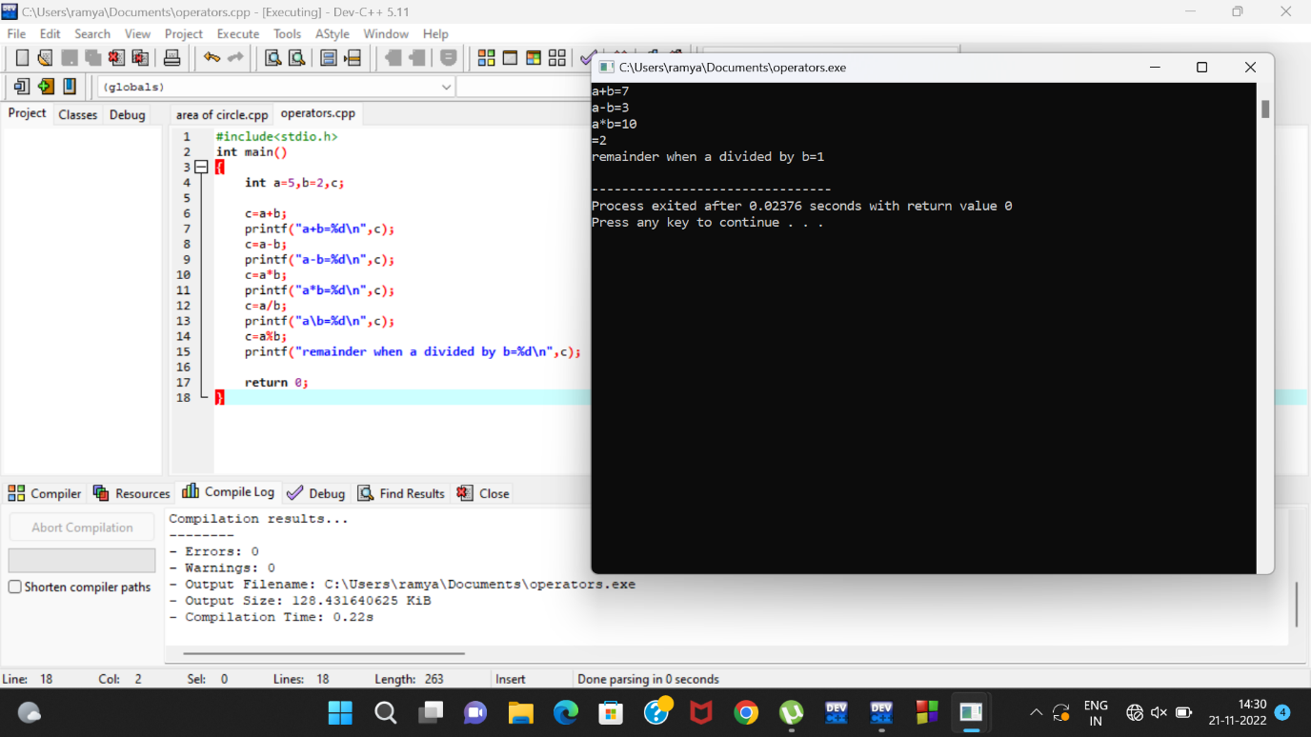

2 INCREMENT AND DECREMENT: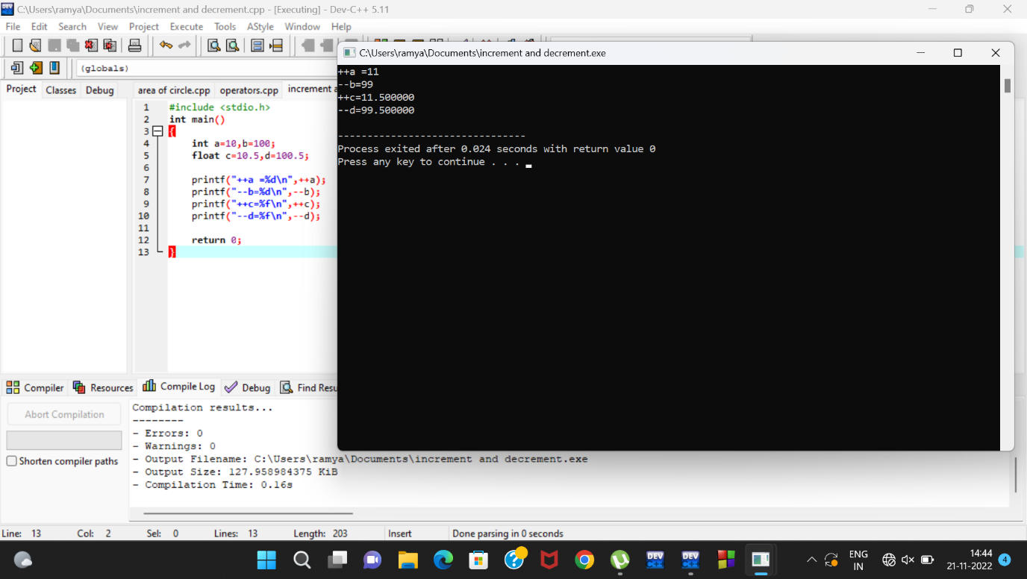

3 COMPARISION BETWEEN INTEGERS(MAX VALUE):

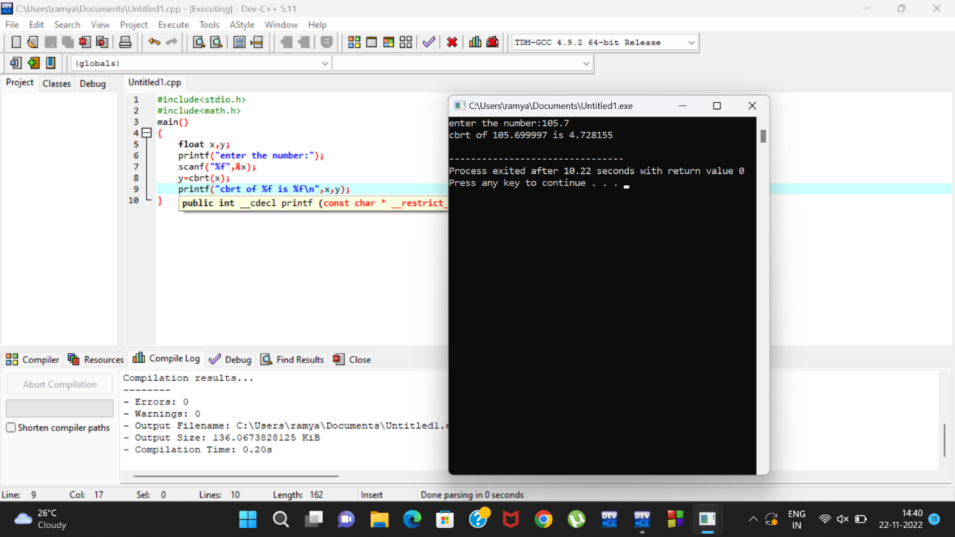

4 CUBE ROOT OF NUMBERS(FLOATS):

5 User defined function:

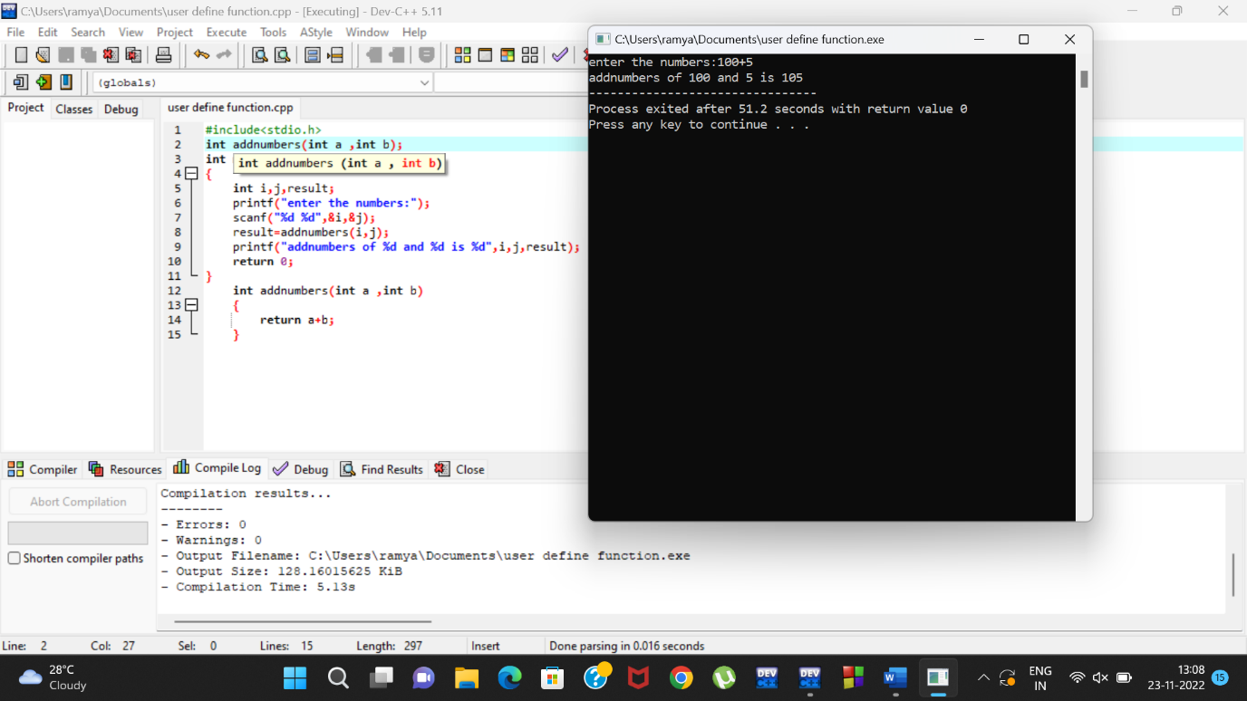

6 Else if statement:

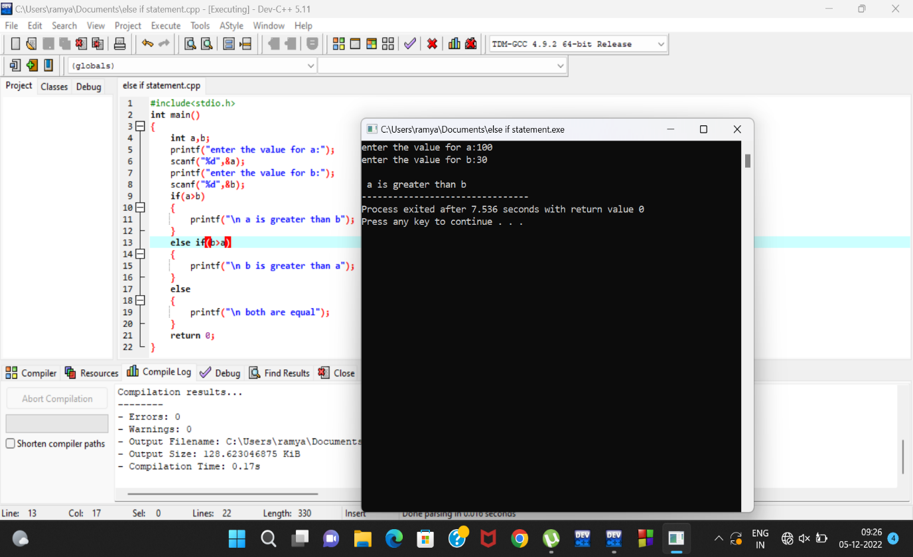

7 Switch statement: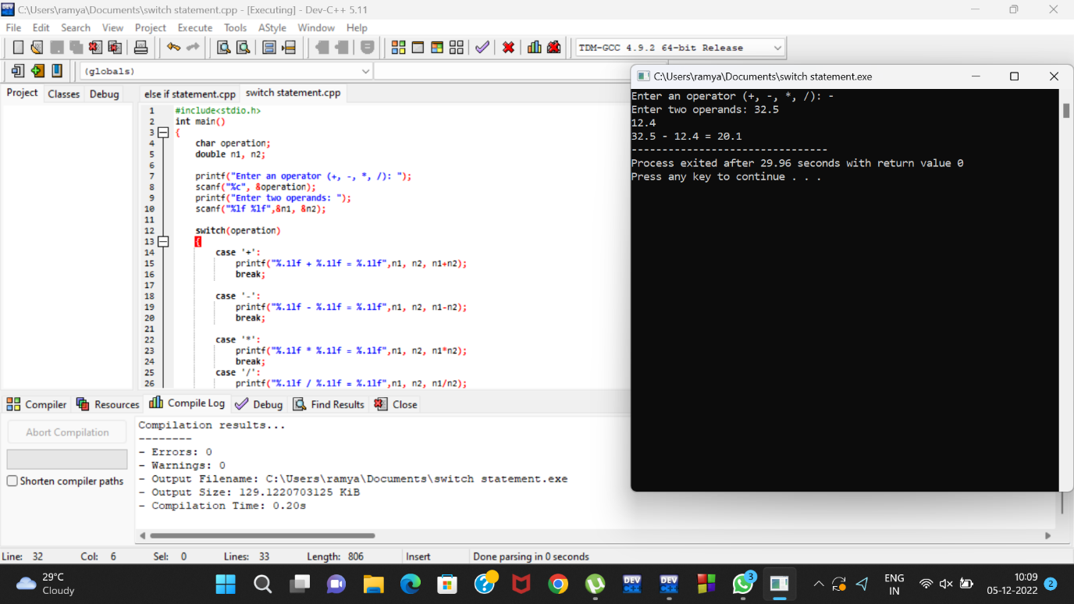

8 While loop statement:

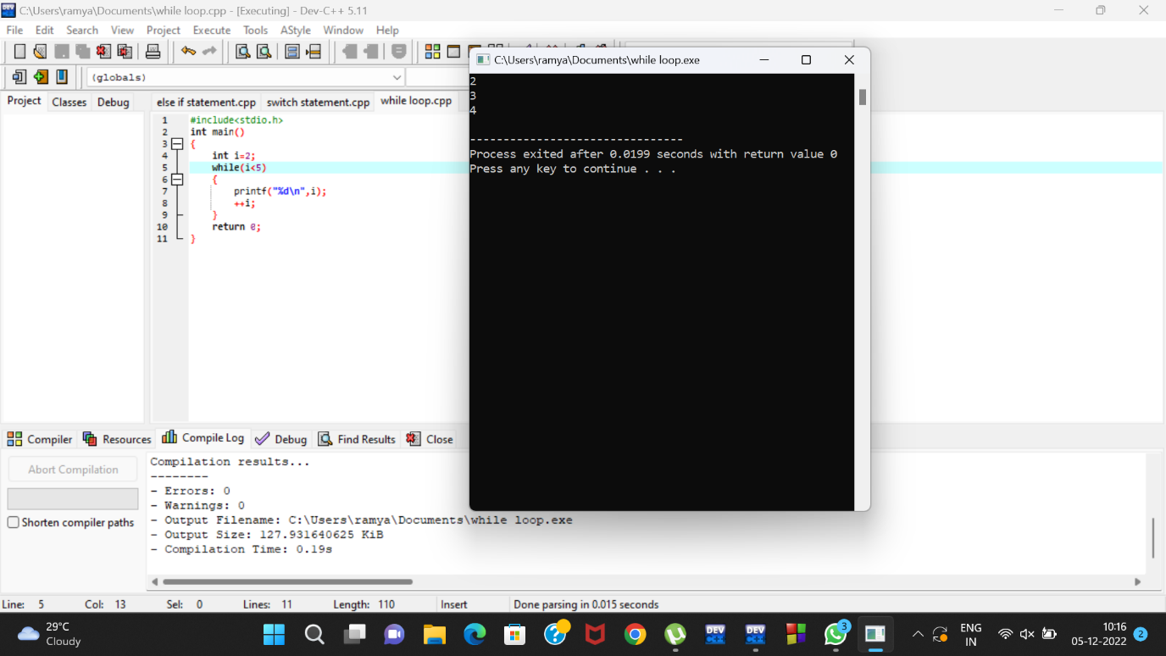

9 One dimensional statement:

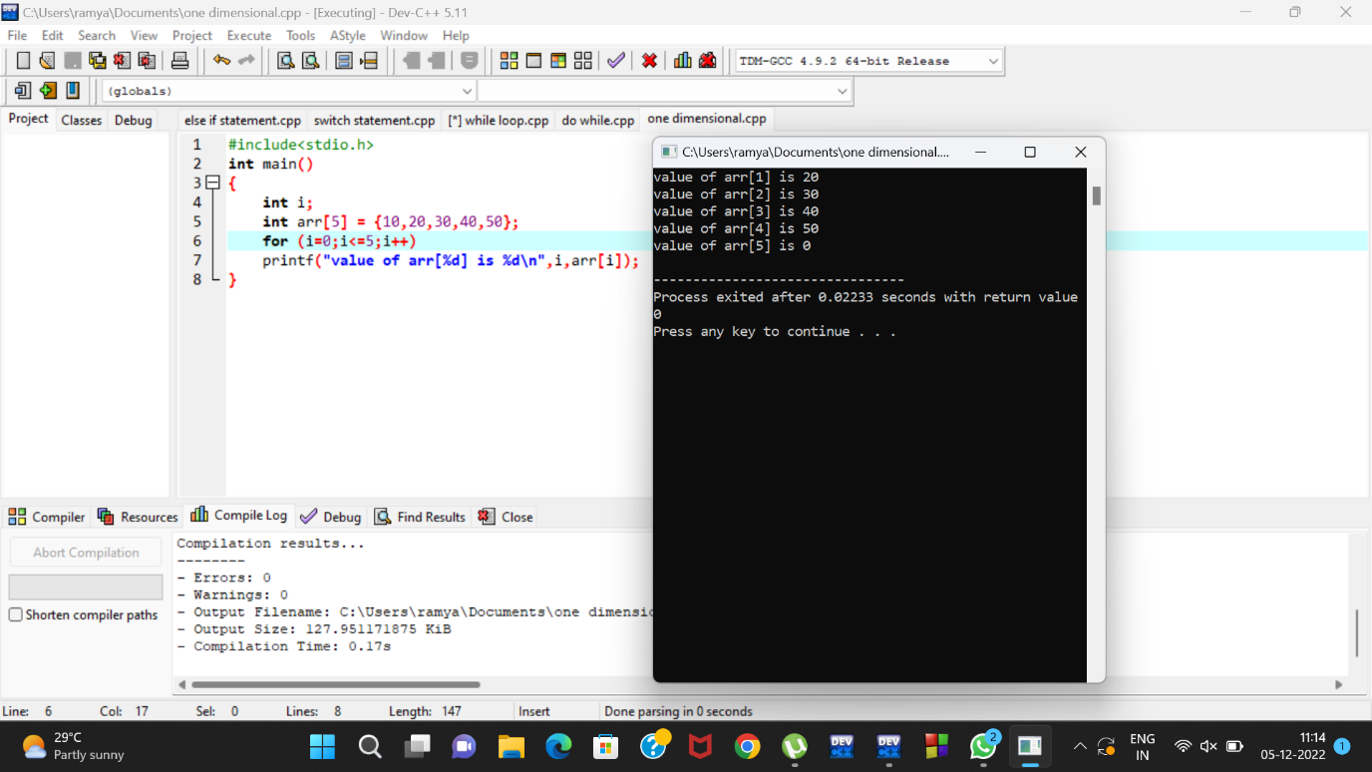

10 Pointers: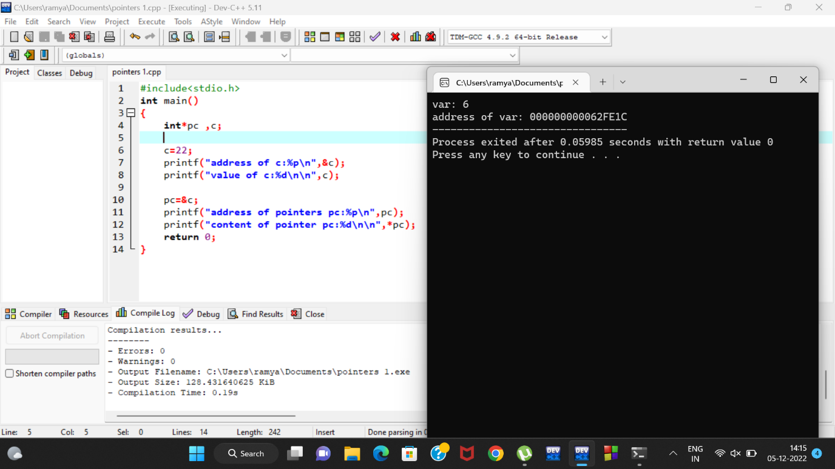

11 Structure: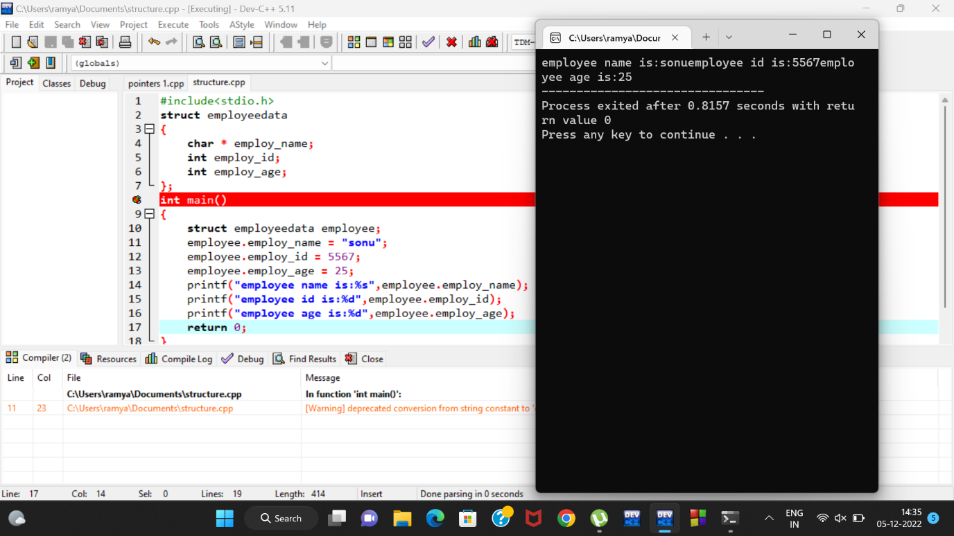

12 Break:

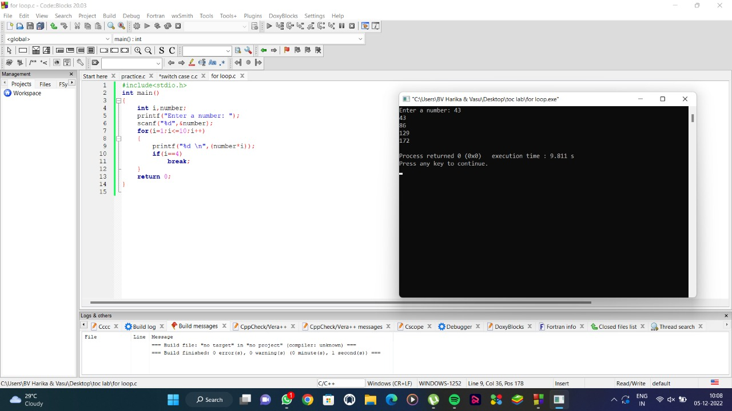

13 Two dimensional:

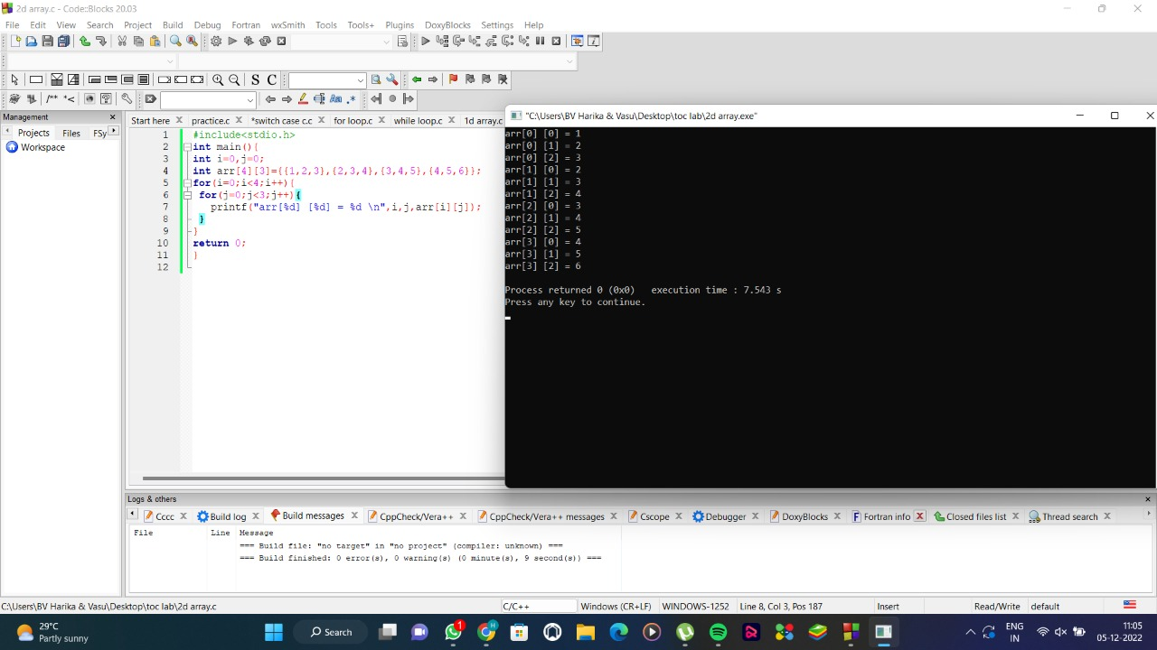

14 For loop:

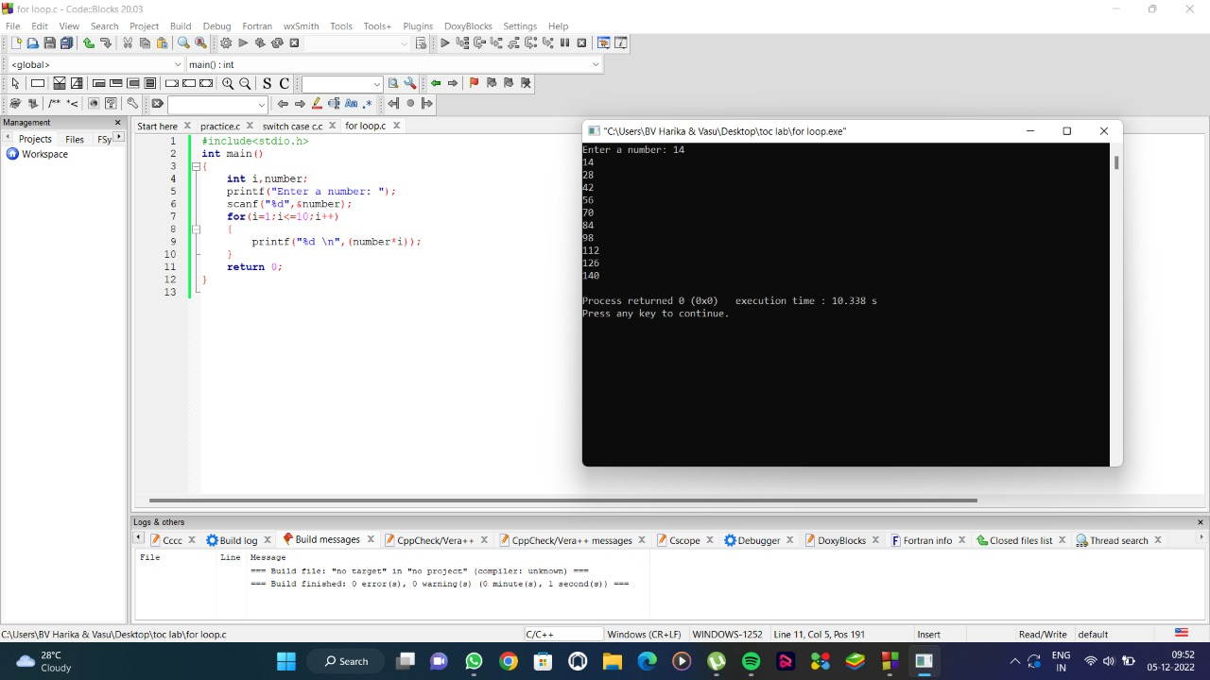

15 Do while loop:

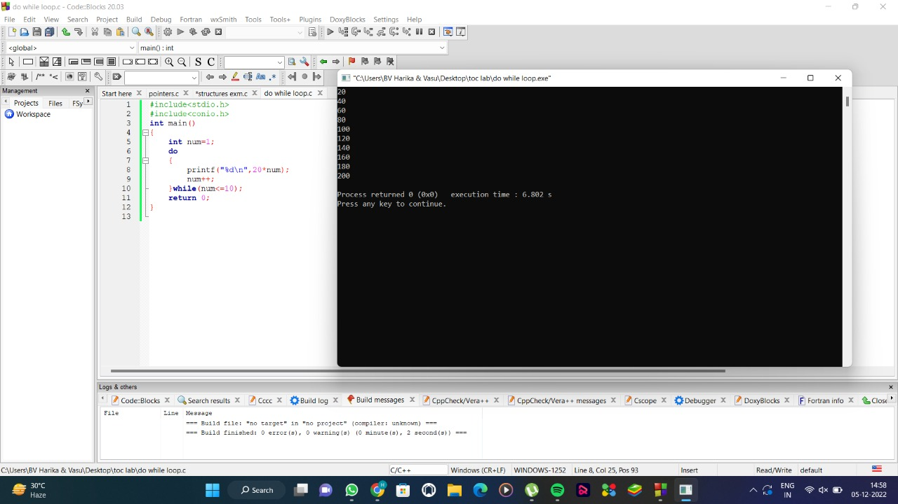

16 Break loop:

